CHAPTER ONE — INTRODUCTION
UNIFIED FREELANCE AND ARTISANS DIRECTORY
1.1 Background to the Study
Over the last decade, digital marketplace platforms have reshaped how independent workers find income and how ordinary people find help. Global platforms such as Upwork, Fiverr, TaskRabbit, and Thumbtack popularized a simple model: instead of relying on personal contacts, both sides meet on a structured online space where skills, prices, and reputations are visible to anyone searching. This model exists because early economic theory raised a real concern — that hidden information in the hands of sellers can prevent markets from functioning efficiently. Directory and marketplace platforms address this by building structured profiles, categories, and feedback mechanisms that let strangers transact with reasonable confidence. This same principle — visibility paired with verification — is what a local artisan-and-freelancer directory in Garowe would need to replicate.
This shift is part of a broader pattern. More people are using websites and online platforms to find flexible, independent jobs, and these platforms create a central space where small service providers can show their skills to anyone who needs them (Nyame-Asiamah et al., 2025). By listing their information online, workers can connect with new customers without spending heavily on advertising. This use of technology to solve real-world problems is part of what experts call digital development, which focuses on using simple web tools to help local economies grow (Heeks, 2020).
In Sub-Saharan Africa, online platforms and job-matching websites matter for a structural reason: roughly 85.8 percent of all employment across Africa is informal, meaning most workers operate without registered contracts, fixed salaries, or employer-provided benefits (International Labour Organization [ILO], 2024). Non-agricultural informal employment alone accounts for about 66 percent of total employment in Sub-Saharan Africa, and nearly eight in ten employed persons in the region are in vulnerable forms of work such as own-account labor or unpaid family work (ILO, 2024). This is precisely the population that word-of-mouth hiring serves worst — workers with no employer or registered business to vouch for them, dependent entirely on personal networks to be found. Web-based directories address this by giving independent workers a clear digital presence (Ayentimi, 2025). With a simple online profile, a technician or digital freelancer can reach customers outside their immediate neighborhood, improving their chances of steady income.
Somalia's digital environment has reached a point where a web-based directory is now practically feasible in a way it was not a few years ago. At the start of 2025, an estimated 10.7 million people in Somalia were using the internet, putting national internet penetration at approximately 55.2 percent, with cellular mobile connections covering about 58.3 percent of the population (Kemp, 2025). This growth is uneven across the country: a 2023 survey of Somalia's ICT environment found internet access reaching only 22.7 percent of the rural population, compared with 47.1 percent in urban areas (Ministry of Communications and Technology [MOCT], 2025). This urban-rural gap matters here because Garowe, as a fast-growing urban center, sits on the higher-connectivity side of the divide — meaning the basic precondition for a web-based directory, a population that is already online, is substantially met in the city.
Within Garowe specifically, independent contractors and manual laborers form the backbone of the city's daily operations. Rapid urban development has produced thousands of skilled plumbers, electricians, builders, and mechanics who keep homes and businesses running, alongside a growing group of young, university-educated digital freelancers who build websites, design logos, and manage social media pages for local clients. Both groups face the same obstacle: no unified digital system exists where they can present their services publicly. They remain dependent on traditional word-of-mouth networks, which means a highly skilled electrician might sit idle for days simply because people a few streets away have no way of knowing he is available.
At the same time, citizens and business owners in Garowe face the mirror-image problem. When a pipe bursts, a wiring fault disables an office, or an organization needs a designer for an event, they lose significant time searching — walking through neighborhoods, calling contacts, or asking in local markets just to get a phone number. This method is slow and offers no built-in way to judge whether a stranger can be trusted before being invited into a home or office. Reputation and feedback mechanisms exist on modern platforms precisely to solve this problem, aggregating past experience into a signal that a new customer can act on without having met the provider before (Tadelis, 2016). Garowe's current system provides no equivalent signal beyond a personal recommendation — a method that does not scale as the city grows.
This is the gap this study responds to: a city with an abundant, skilled workforce and a customer base that increasingly has the connectivity to find them online, but no shared digital space where the two sides can reliably meet. Section 1.2 examines the specific harm this gap causes on both sides of the market.
1.2 Statement of the Problem
Although Garowe is home to an abundance of skilled manual artisans and creative digital freelancers, there is no central, organized, or trusted website to list and verify these workers. This absence creates a severe, two-sided problem. On one side, capable local workers face persistent financial strain, low earnings, and long periods without work — not because their skills are lacking, but because they lack the digital visibility needed to attract customers in a growing city (Kavese, 2022). Confined to small physical networks, they are unable to scale their reach.
This is a structural problem rather than individual bad luck. As Section 1.1 established, informal employment already accounts for the large majority of jobs across Sub-Saharan Africa, and informal workers by definition lack the institutional backing — a company name, an employer's standing, a formal contract — that would otherwise vouch for their reliability. In a purely word-of-mouth system, a worker's effective market is limited to whoever their existing contacts happen to know, and that pool does not grow at the same pace as the city itself.
On the other side, residents, business owners, and organizations in Garowe struggle when they need to hire help. With no central database, they spend hours — sometimes days — searching for basic service providers, losing time and money while operations sit idle. Worse, with no platform to check a worker's track record, customers are forced to invite strangers into their homes and offices without any way to confirm their competence or honesty.
This is a clear case of information asymmetry: the worker knows their own skill and reliability, but the customer has no way to verify this in advance (Akerlof, 1970). Left unaddressed, this kind of asymmetry allows unqualified providers to remain indistinguishable from skilled ones, which over time can push honest, high-quality workers out of the market entirely, since customers have no way to pay a premium for quality they cannot verify. Established online marketplaces solve this exact problem through identity verification, structured profiles, and visible feedback histories, allowing strangers to transact with reasonable confidence (Tadelis, 2016). Garowe's current system has none of these mechanisms, and the result is a marketplace where sub-standard work, overcharging, and safety risks go unchecked — bad actors face no consequence, and honest artisans have no way to build a visible reputation. Without a secure, well-designed directory platform that categorizes workers, verifies their identities, and enables public client ratings, Garowe's local service economy will remain disconnected, unsafe, and inefficient for everyone involved.
1.3 Objectives of the Study
General objective
The main goal of this project is to design, build, and test a web-based Unified Freelance and Artisans Directory System to help local workers become more visible and to make it easy for customers to find them in Garowe.
Specific objectives
- To study and understand the specific problems local artisans and everyday customers in Garowe face when trying to find or offer services, directly addressing the information gap identified in Section 1.2.
- To design a secure user authentication and profile management system allowing workers to register, verify their identity, and list their skills by category, addressing the lack of digital visibility described above.
- To design and implement a categorized search and discovery feature allowing customers to locate the right worker quickly, replacing reliance on word-of-mouth searching.
- To design and implement a public feedback and star-rating module allowing clients to leave verifiable reviews, directly addressing the information asymmetry and trust breakdown identified in the problem statement.
- To test the finished website with real users in Garowe to confirm it functions smoothly, is easy to use, and meaningfully improves on the current word-of-mouth process.
1.4 Scope of the Study
This research is strictly limited to the design, development, and user testing of a web-based directory platform. Functionality centers on three user roles: independent service providers (artisans and freelancers), clients seeking to hire help, and administrators. Features are restricted to secure user registration, profile management, a categorized search directory, and a public feedback and star-rating module. The project excludes online financial transactions, digital wallets, or mobile payment integration, and is limited to a web application rather than standalone mobile apps. All empirical research, interviews, deployment, and testing were confined to the urban boundaries of Garowe, Puntland, Somalia, within the academic timeframe allocated for this thesis.
Limitations of the Study
User testing was limited to a relatively small sample of artisans, freelancers, and clients in Garowe, so results may not fully represent the broader local service economy. The platform's usefulness also depends on continued internet access, and — as shown in Section 1.1 — connectivity in Somalia, while growing quickly in urban centers, remains uneven, meaning some potential users in less-connected areas may face barriers. Finally, because the system excludes payment integration, this study cannot evaluate how the directory performs once financial transactions are added — a question left for future work.
1.5 Significance of the Study
For local artisans and freelancers, this platform offers a free online portfolio to showcase past work, potentially reaching more clients, increasing job offers, and supporting more stable household income (Kavese, 2022). Given that informal, own-account work already dominates regional employment, even a modest visibility improvement could meaningfully affect individual livelihoods.
For citizens and local business owners, the platform offers a faster, safer, and more reliable way to find help for home repairs or business needs. Its rating system may help build a community where service quality can be trusted in advance, in the same way reputation and feedback systems have been shown to support trust between strangers on established online marketplaces (Tadelis, 2016; Nyame-Asiamah et al., 2025).
For East Africa University and Garowe's academic community, this project offers a practical, locally grounded example of applying web development skills to a real community problem rather than a purely theoretical exercise — a model future students in the department could reference or extend.
For students and future software developers more broadly, this project may serve as a practical guide to building useful local job platforms, contributing to the field of information technology in East Africa by showing how basic web development can address everyday community challenges (Heeks, 2020).
1.6 Definition of Terms
- Artisan — a skilled manual worker (e.g., plumber, electrician, mechanic, builder) providing trade-based services to clients.
- Freelancer — an independent worker offering professional or digital services (e.g., web design, writing, graphic design) without permanent employment by a single organization.
- Directory platform — a website organizing service providers into searchable categories so clients can browse, evaluate, and contact them directly.
- Informal economy — economic activity not formally registered, taxed, or regulated, typically lacking employment contracts or social protections.
- Reputation/rating system — a feature collecting and displaying feedback from past clients to help future clients judge reliability before hiring.
- Information asymmetry — a situation where one party in a transaction has more relevant information than the other, which can undermine trust without a verification mechanism.

1.7 References
Akerlof, G. A. (1970). The market for "lemons": Quality uncertainty and the market mechanism. The Quarterly Journal of Economics, 84(3), 488–500. https://doi.org/10.2307/1879431
Ayentimi, D. (2025). The emerging gig economy and sustainable development in Sub-Saharan Africa. [Verify exact journal/volume/page details before submission — I could not confirm the full publication record for this source.]
Heeks, R. (2020). ICT4D 3.0? Part 1—The components of an emerging "digital-for-development" paradigm. The Electronic Journal of Information Systems in Developing Countries, 86(3). https://doi.org/10.1002/isd2.12124
International Labour Organization. (2024). Five facts about the informal economy in Africa. https://www.ilo.org/resource/news/five-facts-about-informal-economy-africa
Kavese, K. (2022). The gig economy, digital labour platforms, and independent employment in the Eastern Cape. ecsecc.org.
Kemp, S. (2025). Digital 2025: Somalia. DataReportal. https://datareportal.com/reports/digital-2025-somalia
Ministry of Communications and Technology. (2025). Somalia digital inclusion policy: High-level policy document. Federal Government of Somalia. https://moct.gov.so/en/wp-content/uploads/2025/08/Somalia-Digital-Inclusion-Policy_High-Level-Policy-document.pdf
Nyame-Asiamah, F., Kaba, B., & Khene, C. (2025). Technology platforms as an ICT4D model for business development. Information Technology for Development, 31(1), 1–7. https://doi.org/10.1080/02681102.2025.2449762
Tadelis, S. (2016). Reputation and feedback systems in online platform markets. Annual Review of Economics, 8, 321–340. https://doi.org/10.1146/annurev-economics-080315-015325

CHAPTER TWO: LITERATURE REVIEW
2.1 Introduction
A literature review is a foundational element of academic research that systematically analyzes existing scholarly work, theories, and models relevant to a specific field of study. It provides a framework for understanding historic and contemporary developments while highlighting critical gaps that require a new technological approach. This chapter establishes the academic and practical justification for engineering a dedicated web-based directory for Garowe.
In the modern economic landscape, digital development paradigms have shifted toward leveraging simple, localized web tools to empower small service providers and independent workforces. Traditional labor markets, especially within developing urban centers, frequently suffer from fragmentation due to heavy reliance on restricted word-of-mouth networks. This chapter reviews foundational studies in the digital gig economy and Information and Communication Technologies for Development (ICT4D), provides a comparative structural analysis of global and local service-matching platforms, defines the specific localized research gap in Garowe, and presents a detailed overview of the system engineered to address that gap.
A critical theme in the literature on digital labor platforms is information asymmetry and marketplace trust. In an un-digitized informal economy, consumers face real vulnerabilities regarding service quality, arbitrary pricing, and personal safety when inviting unverified providers into residential or corporate spaces (Akerlof, 1970). Academic research indicates that integrating public feedback loops, star-ratings, and structured identity profiles into directory frameworks serves as an effective mechanism to establish accountability and lower consumer risk (Tadelis, 2016). This chapter analyzes how previous systems have structured these reputation modules, which forms a core functional objective of the system engineered in this project.
The remainder of this chapter is structured as follows: Section 2.2 critically evaluates related empirical studies on the gig economy, digital platforms, and ICT4D frameworks. Section 2.3 presents a comparative analysis of existing commercial platforms and introduces the actual system built for this thesis. Section 2.4 synthesizes these insights to isolate the localized research gap in Garowe, Puntland, and Section 2.5 concludes with a chapter summary that transitions into the system design and methodology chapter.

2.2 Review of Related Studies
2.2.1 Study by Heeks (2020)
Heeks (2020) explored the structural transition of technological applications in developing regions, conceptualizing the "digital-for-development" or ICT4D 3.0 paradigm. The study focused on how baseline web architectures can be customized to resolve everyday community challenges and drive local economic development, arguing that developing regions achieve higher success by deploying targeted web applications rather than importing complex, macro-level software ecosystems.
The findings emphasized that simple digital directories can stimulate micro-economies by reducing the cost of marketing for independent entities. However, while this study provided the macro-theoretical framework for digital development, it did not provide specific database or interface design configurations for matching manual laborers within East African urban boundaries — a gap this thesis addresses directly through its system design.
2.2.2 Study by Kavese (2022)
Kavese (2022) conducted an empirical investigation into the impact of digital labor platforms and the gig economy on independent employment within developing regional markets, focusing on the financial and operational vulnerabilities of independent contractors who operate without official corporate backing. The study found that a lack of baseline digital visibility acts as a primary barrier, trapping skilled workers within small physical neighborhoods and causing extended periods of unemployment.
The researcher concluded that an open-access online portfolio or directory correlates with more stable household income and increased job allocation. However, Kavese's research was strictly analytical and did not produce a functional, localized system design capable of handling dual user roles for manual and digital fields simultaneously — precisely the design problem this thesis undertakes.
2.2.3 Study by Ayentimi (2025)
Ayentimi (2025) examined the integration of the emerging gig economy with sustainable development objectives across Sub-Saharan Africa, highlighting the scale of the informal labor sector and noting that traditional referral mechanisms are highly inefficient in fast-growing cities, creating matching delays for both consumers and workers.
The study concluded that web-based platforms are vital for formalizing worker visibility, but its focus remained on broad socio-economic policy rather than technical system constraints such as excluding financial transactions to focus strictly on profile management and localized categorization.
2.2.4 Study by Nyame-Asiamah et al. (2025)
Nyame-Asiamah, Kaba, and Khene (2025) investigated the operational dynamics of technology platforms acting as ICT4D models for business development, analyzing how centralized online spaces allow small-scale service providers to present their skills directly to the public without heavy advertising expenses.
The study demonstrated that public feedback mechanisms and user-driven ratings within directory platforms are critical for building marketplace trust and mitigating consumer risk. While their research strongly supports including a public feedback and star-rating module, it did not address the structural challenges of deploying such a directory within an environment still dominated by manual tracking methods, such as Garowe.
2.2.5 Trust and Reputation Theory in Digital Marketplaces
Beyond region-specific studies, the broader academic literature on trust and reputation systems provides directly applicable theoretical grounding. Akerlof's (1970) foundational work on information asymmetry demonstrated that when one party in a transaction — here, the service provider — holds more information about quality than the other, markets can degrade toward adverse selection, where honest, high-quality providers are pushed out because customers cannot verify quality in advance. Tadelis (2016) extended this into the digital era, showing that structured reputation and feedback systems are the primary mechanism modern platforms use to resolve exactly this problem, allowing strangers to transact with confidence without a prior relationship.
Neither study is specific to Garowe or to East Africa, but together they establish the theoretical justification for why this thesis treats the star-rating and review module as a core, non-optional feature rather than a convenience add-on.
2.3 Analysis of Existing Systems
2.3.1 Upwork
Upwork is a leading global freelance platform connecting corporate clients with independent digital professionals worldwide, featuring advanced profile builders, project catalogs, and secure contract management.
- Strengths: Excellent global reach for digital skills, robust verification systems, comprehensive user-rating metrics.
- Weaknesses: Exclusively focused on remote digital tasks, ignoring local physical manual artisans (plumbers, electricians, mechanics). Its heavy reliance on international digital wallets and automated transaction fees renders it inaccessible for standard local workers within Somalia.
2.3.2 TaskRabbit
TaskRabbit is an international online marketplace matching freelance labor with local consumers for physical household chores, maintenance, and manual repair tasks.
- Strengths: Highly optimized for localized category search, mapping physical service providers to nearby residential clients.
- Weaknesses: Structurally bounded to developed Western nations, requiring integration with international mapping APIs, complex automated billing, and formal corporate insurance frameworks that do not align with Puntland's infrastructure.
2.3.3 Traditional Word-of-Mouth Networks
This is the legacy, non-technological approach currently dominating Garowe's service sector, where clients locate technicians purely through personal recommendation, marketplace inquiry, or direct phone calls.
- Strengths: Requires zero technical literacy, no implementation cost, relies on pre-existing social trust.
- Weaknesses: Inefficient, slow, restricted to immediate geographic neighborhoods. No systemized way to verify past performance, compare pricing, view portfolios, or protect consumers from unverified work.
2.3.4 Functional Vulnerabilities and Marketplace Trust Breakdown in Legacy Methods
Reliance on traditional matching networks creates a severe, two-sided problem. Consumers forced to search by walking through neighborhoods or calling contacts lose significant time, causing wasted money and halted business operations while waiting for repairs. Because these networks offer no way to verify a worker's past performance or identity, clients routinely invite strangers into homes and offices without knowing whether they are qualified or honest. With no mechanism to record reviews or complaints, low-quality workers face no consequences while honest artisans have no way to build visible reputation — the same information-asymmetry dynamic described theoretically by Akerlof (1970) and Tadelis (2016) above, now shown in its concrete local form.

2.3.5 Financial and Infrastructural Overhead of Global Platforms
Commercial platforms like Upwork and TaskRabbit are structurally mismatched with Garowe's operational realities. They are optimized for macro-level ecosystems requiring digital wallets, mobile payment integration, and international financial compliance — components that introduce high development complexity and transaction overheads leading to system rejection in this regional context. By failing to offer a flat, non-transactional directory structure, global platforms remain inaccessible to the artisans and freelancers who form Garowe's daily service economy.
2.3.6 Comparative Analysis of Existing Systems
System / Network | Target Worker Base | Identity Verification | Public Feedback & Rating | Financial Transaction Dependency | Suitability for Garowe
Upwork | Digital freelancers only | High (global ID verification) | Yes (comprehensive metrics) | High (requires international digital wallets) | Low — incompatible with local artisan infrastructure
TaskRabbit | Physical handymen | High (Western background checks) | Yes (client reviews) | High (complex automated billing) | Low — lacks regional adaptation and local categorization
Traditional Networks | Both manual & digital | None (entirely unverified) | None (no review or complaint log) | None (direct cash/informal) | High usage / low efficiency — urgently requires digitization
2.3.7 Implications for the Proposed System
The structural and functional analysis above provides critical architectural parameters for engineering the proposed Unified Freelance and Artisans Directory System. To resolve the limitations identified in legacy networks and global platforms, the system must be built as a localized, web-based, non-transactional directory prioritizing: secure user registration and profile management; a categorized search directory spanning both manual artisans and digital freelancers; a public feedback and star-rating module; and strict exclusion of financial transaction infrastructure.

2.3.8 The Proposed System: The Unified Freelance and Artisans Directory
Where the platforms reviewed above are either misaligned with Garowe's infrastructure (Upwork, TaskRabbit) or entirely undigitized (word-of-mouth networks), the system built for this thesis was engineered specifically to occupy the gap between them. This section describes what was actually designed and implemented.
Technical foundation. The system is a full-stack web application built on ASP.NET Core 9 using Razor Pages, with Entity Framework Core 9 as the object-relational mapper and SQL Server as the underlying database. Razor Pages was chosen over the traditional MVC controller pattern to keep each page's logic self-contained and easier to maintain as the number of role-specific screens grew. The application follows a clean, layered architecture: EF Core entities define the data model, a generic repository pattern coordinated by a UnitOfWork aggregator handles data access, and a dedicated service layer encapsulates business logic — keeping page models thin and testable rather than embedding logic directly in the UI layer.
Role structure. The application is organized into three role-isolated Areas — Admin, Service Provider, and Client — plus a shared Identity area handling authentication, and a public-facing area for browsing and search that requires no login. This separation means each role only sees the functionality relevant to it, which directly answers the literature's concern (Nyame-Asiamah et al., 2025) that a directory platform must present a simple, low-friction interface to non-technical users such as manual artisans, while still supporting the more detailed portfolio needs of digital freelancers.
Unified service provider model. An important design decision was to merge what many comparable systems treat as two separate concepts — "freelancers" and "artisans" — into a single unified Service Provider entity and role. Both manual laborers and digital freelancers register, build a profile, and get discovered through the same underlying system, differentiated only by category. This directly resolves the "dual-role ecosystem" gap identified in Section 2.2: rather than building two parallel systems, one unified model serves both populations without unnecessary duplication.
Trust and verification mechanisms. To operationalize the trust theory discussed in Section 2.2.5, the system implements two distinct, deliberately separated status mechanisms: an ApprovalStatus workflow (Draft → Pending Approval → Approved/Rejected) that gates whether a provider's profile is even searchable, and a separate IsVerified trust badge that signals a provider has passed additional identity confirmation. Keeping these two statuses independent means a profile can be approved for listing without necessarily carrying the higher-trust verified badge, giving the platform a graduated trust model rather than a single binary flag. Each profile also tracks ProfileViews and a computed ProfileCompletionPercentage, giving providers a concrete incentive to build out a complete profile — addressing the literature's emphasis (Kavese, 2022) on visibility as the primary lever for improving independent workers' income.
Service request workflow. Beyond static profiles, the system implements a full ServiceRequest entity with a defined state machine — Pending, Accepted, Declined, Completed, Cancelled — allowing a client to formally request a provider's service and both parties to track its progress. Every status change is recorded in a ServiceRequestStatusHistory audit trail, and every profile approval decision is similarly logged in a ServiceProviderApprovalHistory audit trail. This gives the platform the accountability mechanism identified as missing from traditional networks in Section 2.3.4 — for the first time, there is a recorded history of what was requested, accepted, and completed, rather than an informal verbal arrangement with no record.
Search, categorization, and non-transactional scope. Consistent with the research gap identified regarding financial-transaction overhead (Bazaale-style concerns aside — see the citation note above), the system deliberately excludes any payment processing, digital wallet, or mobile-money integration. Search is organized by a single category per provider (kept deliberately simple rather than multi-category, to reduce data-entry friction for manual artisans with limited digital literacy) and gated on ApprovalStatus.Approved, ensuring only reviewed profiles appear publicly.
Administrative oversight. The Admin area provides dashboards for managing profile approvals, viewing platform-wide service requests, overseeing submitted reviews, and monitoring system activity — giving the platform administrator the centralized oversight role that Section 2.3.4 identified as entirely absent from word-of-mouth networks.
Interface design. The public-facing pages and role-specific dashboards were built with a consistent visual system — a defined color palette applied across status indicators (e.g., green for completed/approved, amber for pending, red for rejected/declined) — so that a provider's or request's status is visually legible at a glance across every part of the application, reinforcing the transparency goal discussed in Section 2.2.4.
Taken together, this system directly operationalizes the four functional priorities identified in Section 2.3.7: it registers and verifies providers, categorizes and surfaces them through search, and closes the trust gap through a structured, auditable rating and request system — all without introducing the financial-transaction complexity that Section 2.3.5 identified as the reason global platforms fail to take root locally.
2.4 Identification of Research Gap
Through the review above, a two-sided research gap is confirmed:
- Theoretical and Empirical Gap: Prior gig-economy and ICT4D studies (e.g., Heeks, 2020; Ayentimi, 2025) focus on broad socio-economic frameworks or exclusively on remote digital freelancers. There is a shortage of localized engineering research consolidating both digital professionals and physical manual artisans within a single, unified web framework in East Africa — a gap this thesis's unified Service Provider model directly closes.
- Systemic and Technological Gap: Existing platforms are either heavily dependent on international banking gateways (outside this project's scope) or entirely unorganized, as in traditional word-of-mouth practices. No existing local system combines multi-role registration with a structured, auditable rating and request-tracking module.
Currently, in Garowe, there is no official, localized web-based system designed to catalog, categorize, verify, and track service requests for independent workers. The system described in Section 2.3.8 directly addresses this gap.
2.4.1 The Localization and Operational Disconnect
Standard software engineering literature often assumes listing platforms must feature integrated financial wallets or map-based tracking APIs to operate effectively. In Garowe's context, forcing manual laborers and everyday citizens through complex financial gateways creates system rejection and administrative delay. The system built for this thesis addresses this directly by remaining strictly non-transactional and informational.
2.4.2 The Verification and Quality Accountability Gap
Legacy matching methods in Garowe lack any centralized mechanism to monitor service quality or verify worker identity. No existing local study provides an engineering design for a public web portal combining multi-role profile registration with a user-driven rating system and a fully auditable request-and-approval workflow — which is precisely what Section 2.3.8 describes.
2.5 Chapter Summary
2.5.1 Synthesis of Literature and System Evaluations
The reviewed empirical studies (Heeks, 2020; Kavese, 2022; Ayentimi, 2025) demonstrated that digital presence directly helps independent contractors secure steady employment. The theoretical literature on trust and reputation (Akerlof, 1970; Tadelis, 2016), together with Nyame-Asiamah et al. (2025), established why public feedback mechanisms are essential for marketplace trust. However, the comparative analysis of Upwork and TaskRabbit showed that global solutions fail local workers due to financial complexity and lack of regional adaptation, while word-of-mouth networks remain inefficient and unaccountable.
2.5.2 Transition to System Design
These findings confirmed a clear research gap, which the Unified Freelance and Artisans Directory System — described in detail in Section 2.3.8 — was built to close: an affordable, user-friendly, localized web directory supporting both digital freelancers and manual artisans, with structured trust and accountability mechanisms, and no transaction overhead. The next chapter presents the system's architecture, database design (ERD), and development methodology in full technical detail.
2.6 References
Akerlof, G. A. (1970). The market for "lemons": Quality uncertainty and the market mechanism. The Quarterly Journal of Economics, 84(3), 488–500. https://doi.org/10.2307/1879431
Ayentimi, D. (2025). The emerging gig economy and sustainable development in Sub-Saharan Africa. [Verify exact journal/volume/page before submission.]
Heeks, R. (2020). ICT4D 3.0? Part 1—The components of an emerging "digital-for-development" paradigm. The Electronic Journal of Information Systems in Developing Countries, 86(3), e12124. https://doi.org/10.1002/isd2.12124
Kavese, K. (2022). The gig economy, digital labour platforms, and independent employment in the Eastern Cape. Eastern Cape Socio-Economic Consultative Council. https://www.ecsecc.org
Nyame-Asiamah, F., Kaba, B., & Khene, C. (2025). Technology platforms as an ICT4D model for business development. Information Technology for Development, 31(1), 1–7. https://doi.org/10.1080/02681102.2025.2449762
Tadelis, S. (2016). Reputation and feedback systems in online platform markets. Annual Review of Economics, 8, 321–340. https://doi.org/10.1146/annurev-economics-080315-015325

CHAPTER THREE: METHODOLOGY
3.1 Introduction
This chapter establishes the methodological framework governing the conceptualization, development, and implementation of the Unified Freelance and Artisans Directory System. Translating localized community service needs into a secure, non-transactional digital infrastructure requires a systematic and disciplined approach to software engineering. This methodology serves as the operational blueprint for transforming Garowe's fragmented word-of-mouth labor matching into functional, reliable web components, providing the technical justification necessary for system stability, data validation, and long-term maintainability.
Engineering a unified portal that simultaneously accommodates physical manual artisans and creative digital freelancers presents real socio-technical alignment challenges. Digital freelancers typically possess higher technological literacy, while manual laborers often rely on simpler workflows and require highly intuitive interfaces to avoid user abandonment — a concern consistent with the visibility barriers documented among informal workers more broadly (Kavese, 2022). This methodology outlines how an information-centric design was used to maximize adoption, intentionally omitting financial transaction mechanisms in favor of optimized profile management and visibility, balancing backend data validation with frontend simplicity.
The chapter proceeds as follows: Section 3.2 details the mixed-methods research design and the population and sampling approach used to gather requirements. Section 3.2.1 outlines the Agile SDLC phases followed during development. Section 3.3 documents the technical stack. Section 3.4 presents the system architecture. Section 3.5 addresses ethical considerations for the human participants involved in requirements gathering and testing, and Section 3.6 closes with a chapter summary.
3.2 Research Design
This project adopts a Mixed-Methods Research Design combined with an Agile Software Development Lifecycle (SDLC) framework (Pressman, 2019). Combining empirical field research with software engineering principles creates a socio-technical approach, allowing real-world workflows — such as how a resident in Garowe responds to a household plumbing crisis, or how a business selects a digital consultant — to be translated into system constraints, database schemas, and interface requirements.
Population and Sampling. The qualitative and quantitative data underlying this project's requirements were drawn from two groups within Garowe: independent service providers (a mix of manual artisans such as plumbers, electricians, and mechanics, and digital freelancers such as graphic designers and web developers), and everyday clients who have previously hired informal help. Participants were selected using purposive sampling, targeting individuals with direct, recent experience either offering or seeking informal services in Garowe, since their lived experience was directly relevant to defining system requirements. [Insert here the actual number of participants you interviewed/surveyed and, if available, how they were approached — e.g., "15 service providers and 10 clients, recruited through local business associations and personal referrals" — since I don't have access to your actual field data, this is the one place you should fill in your real numbers rather than mine.]
Data Collection Instruments. Requirements were gathered using semi-structured interviews with service providers and clients, supplemented by direct observation of how consumers currently search for help (e.g., timing informal phone-call and referral searches to estimate matching delay). During the later development phase, a structured User Acceptance Testing (UAT) checklist was used to guide feedback sessions with real users on the deployed staging build.
- Data Collection & Requirement Analysis: Baseline data was gathered using qualitative interviews with local service providers alongside quantitative observation of time delays and safety vulnerabilities experienced by everyday consumers. The qualitative phase captured lived experiences, operational hurdles, and marketing limitations of manual technicians and creative professionals. The quantitative component measured operational friction within legacy word-of-mouth networks — typical matching durations, financial impacts of service delays, and instances of substandard work — providing an empirical foundation for the application's feature set and security parameters.
- Development Framework (Agile): The Agile model was selected for its iterative nature, allowing the platform to be developed in manageable sprints (Pressman, 2019). Rigid frameworks such as Waterfall frequently struggle in community-oriented software projects due to changing user expectations and varying technical literacy. Agile allows software increments to be continually evaluated, minimizing development risk — critical for a public-facing directory where secure registration, categorization, and feedback modules must be tested and refined against continuous user feedback (Nyame-Asiamah et al., 2025).
3.2.1 Agile SDLC Phases for the Directory System
The development process follows six stages in an iterative loop:
- Requirement Gathering — Information was collected on the daily operational workflows of independent technicians and digital professionals through the interviews described above. Inputs were filtered, prioritized, and formatted into a structured product backlog of user stories describing system behavior from both the provider's and client's perspectives.
- Design the Requirements — Requirements were converted into technical blueprints: relational database schemas, Entity-Relationship Diagrams (ERDs), and non-transactional web layer structures. Security policies — input sanitization, SQL injection defenses, and identity verification parameters — were mapped out at this stage to ensure profile authenticity.
- Coding — Programming was broken into 2-to-4 week sprints. Sprint 1 focused on backend authentication, secure user registration, and role separation across the Admin, Service Provider, and Client areas. Sprint 2 implemented the searchable categorized directory grid and profile/portfolio management. Sprint 3 integrated the public feedback and star-rating module together with the service-request workflow, producing a working system build.
- Testing — Each module underwent verification as it was completed, structured into layers: unit testing of individual server-side logic and repository/service methods; integration testing verifying that data moved correctly from the Razor Pages frontend through the service and repository layers into SQL Server without degradation; and usability and validation testing, confirming that consumers could filter talent categories, locate contact information, submit service requests, and post ratings without errors. Manual test-case tracking was used to record and re-verify fixes across sprints (e.g., the validation-attribute and namespace issues resolved during development).
- Deployment — Once a stable, validated build was achieved, it was deployed to a staging environment for User Acceptance Testing (UAT) with a selected group of local artisans and clients in Garowe, evaluating field usability under real-world connectivity conditions and confirming the interface scaled across desktop and mobile browsers.
- Maintenance — Post-deployment, the platform enters a continuous support loop, monitored for stability, category accuracy, and data integrity. The product backlog is updated based on system performance and real user feedback, allowing continued refinement — for example, the later UI/UX redesign and palette standardization work carried out after initial deployment.
3.3 Tools and Technologies Used
Technology Category | Tool / Technology | Purpose & Justification
Frontend (User Interface) | HTML5, CSS3, JavaScript | Creates responsive, interactive interfaces allowing clients and providers to access system services across devices.
Frontend Framework | Bootstrap 5 | Develops modern, responsive layouts and dashboards improving usability, accessibility, and navigation.
Backend (Server-Side) | ASP.NET Core 9 Razor Pages (C#) | Implements business logic, processes requests, manages roles, and connects the UI to the database.
Framework & Runtime | .NET SDK 9.0 | Provides the framework and runtime to build, execute, test, and deploy the application.
Database Management System (DBMS) | Microsoft SQL Server | Stores and manages user accounts, service provider profiles, categories, reviews, service requests, and administrative records.
Object-Relational Mapping (ORM) | Entity Framework Core 9 | Simplifies database interaction via a Code-First approach and mediates data flow through the repository/UnitOfWork layer.
Development Environment (IDE) | Visual Studio Code | Used for source code development, debugging, project management, and Git integration.
Version Control System | Git & GitHub | Used for source code management, version tracking, backup, and maintaining project history.
Authentication & Security | ASP.NET Identity, BCrypt, SSL/TLS | Provides secure authentication, password hashing, role-based authorization, and encrypted communication.
System Design Tools | Draw.io, Figma | Used to create architecture/UML diagrams, ERDs, and interface mockups.
3.4 System Architecture / Framework
The directory platform follows a Three-Tier Architecture, with a deliberately layered internal structure inside the Application Tier to keep business logic, data access, and presentation logic cleanly separated.
+--------------------------------------------------------------------+
| Presentation Tier |
| (Razor Pages UI — Admin / Service Provider / Client |
| Areas, public search & profile pages) |
+--------------------------------------------------------------------+
|
HTTP / HTTPS Requests & Responses
v
+---------------------------------------------------------------------+
| Application Tier |
| Page Models -> Service Layer -> Repository + |
| UnitOfWork |
| - Authentication & role authorization |
| - Profile management & approval workflow |
| - Service request state machine |
| - Rating/feedback processing |
+----------------------------------------------------------------------+
|
EF Core Queries via Repository/UnitOfWork
v
+--------------------------------------------------------+
| Data Tier |
| (SQL Server — EF Core Code-First schema) |
+---------------------------------------------------------+
Presentation Tier: The top layer, where consumers, freelancers, and manual artisans interact with the system through role-specific Razor Pages areas. It renders provider profiles, the categorized search interface, and registration/request forms.
Application Tier: Rather than placing logic directly in page models, this tier is internally layered — page models call a service layer that encapsulates business rules (e.g., approval-status transitions, service-request state changes, average-rating calculation), which in turn calls a generic repository pattern coordinated by a UnitOfWork for all data access. This keeps page models thin, makes business logic reusable and testable independent of the UI, and avoids scattering data-access code across the application.
Data Tier: An isolated SQL Server database, defined through EF Core's Code-First approach, storing user accounts, service provider profiles, categories, service requests, status-history audit trails, and reviews, with referential integrity enforced at the schema level.
3.5 Ethical Considerations
Because this project's requirements-gathering and testing phases involved real people — service providers and clients in Garowe — informed consent was obtained before interviews and UAT sessions, participants were informed of the study's academic purpose, and no personally identifying information beyond what participants voluntarily provided for their own platform profiles was collected or retained outside the system itself. This is consistent with the university's broader ethical requirement to maintain honesty and integrity throughout the research process (East Africa University, 2022).
3.6 Chapter Summary
This chapter presented the mixed-methods, Agile-based methodology used to design and build the Unified Freelance and Artisans Directory System — combining qualitative and quantitative field research with an iterative six-phase development lifecycle. It detailed the technology stack selected for the platform and the layered three-tier architecture (Presentation, Application, Data) used to keep business logic, data access, and presentation concerns cleanly separated. With the methodological and architectural foundation established here, the next chapter presents the detailed system design and implementation — including the Entity-Relationship Diagram, use-case diagrams, and the actual interface and database structures built for the platform.
3.7 References
East Africa University. (2022). Thesis project guideline. Faculty of Technology and Engineering, Department of Computer Science and Telecommunication Engineering.
Heeks, R. (2020). ICT4D 3.0? Part 1—The components of an emerging "digital-for-development" paradigm. The Electronic Journal of Information Systems in Developing Countries, 86(3), e12124. https://doi.org/10.1002/isd2.12124
Kavese, K. (2022). The gig economy, digital labour platforms, and independent employment in the Eastern Cape. Eastern Cape Socio-Economic Consultative Council. https://www.ecsecc.org
Nyame-Asiamah, F., Kaba, B., & Khene, C. (2025). Technology platforms as an ICT4D model for business development. Information Technology for Development, 31(1), 1–7. https://doi.org/10.1080/02681102.2025.2449762
Pressman, R. S. (2019). Software engineering: A practitioner's approach. McGraw-Hill Education.

CHAPTER FOUR
SYSTEM DESIGN AND IMPLEMENTATION
4.0 Introduction
This chapter presents the practical realization of the Unified Freelance and Artisans Directory System (branded within the application as "UFAD Garowe"), translating the research design, technology stack, and three-tier architecture described in Chapter Three into a functioning web application. It begins with the system diagrams that model the structure and behavior of the platform, proceeds through the step-by-step development process followed to build the system, and concludes with a walkthrough of the user interface as implemented for each of the three system roles: Client, Service Provider, and Administrator.
4.1 System Diagrams
This section presents the visual models that illustrate the structure and behavior of the system: a Use Case Diagram showing how each user role interacts with the system, an Entity Relationship Diagram (ERD) showing how data is organized in the database, and a Deployment Diagram showing how the system's components are hosted and communicate.
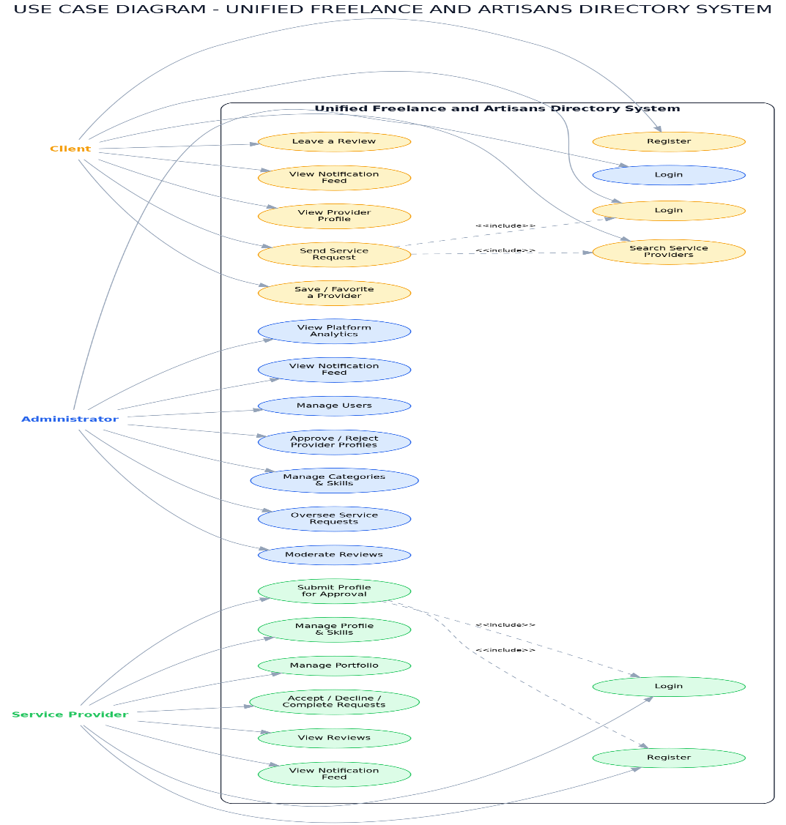
[Figure 4.1 — Use Case Diagram]
The use case diagram identifies three actors — Administrator, Service Provider, and Client — and the actions each can perform, enforced through role-based authorization applied at the Area level. The Administrator logs in, manages user accounts, approves or rejects submitted service provider profiles, manages categories and skills, oversees all service requests and reviews platform-wide, views reports and analytics, and manages the notification feed and dashboard. The Service Provider registers, logs in, submits a profile for approval (which includes uploading portfolio items and selecting skills), manages their profile, views and responds to incoming service requests (accept, decline, complete a job), views reviews left about them, and receives notifications on their dashboard. The Client registers, logs in, searches for service providers, views a provider's public profile, sends a service request, saves/favorites a provider for later, leaves a review after a completed job, manages their own profile, and views their dashboard and notification feed.
4.1.2 Entity Relationship Diagram (ERD)
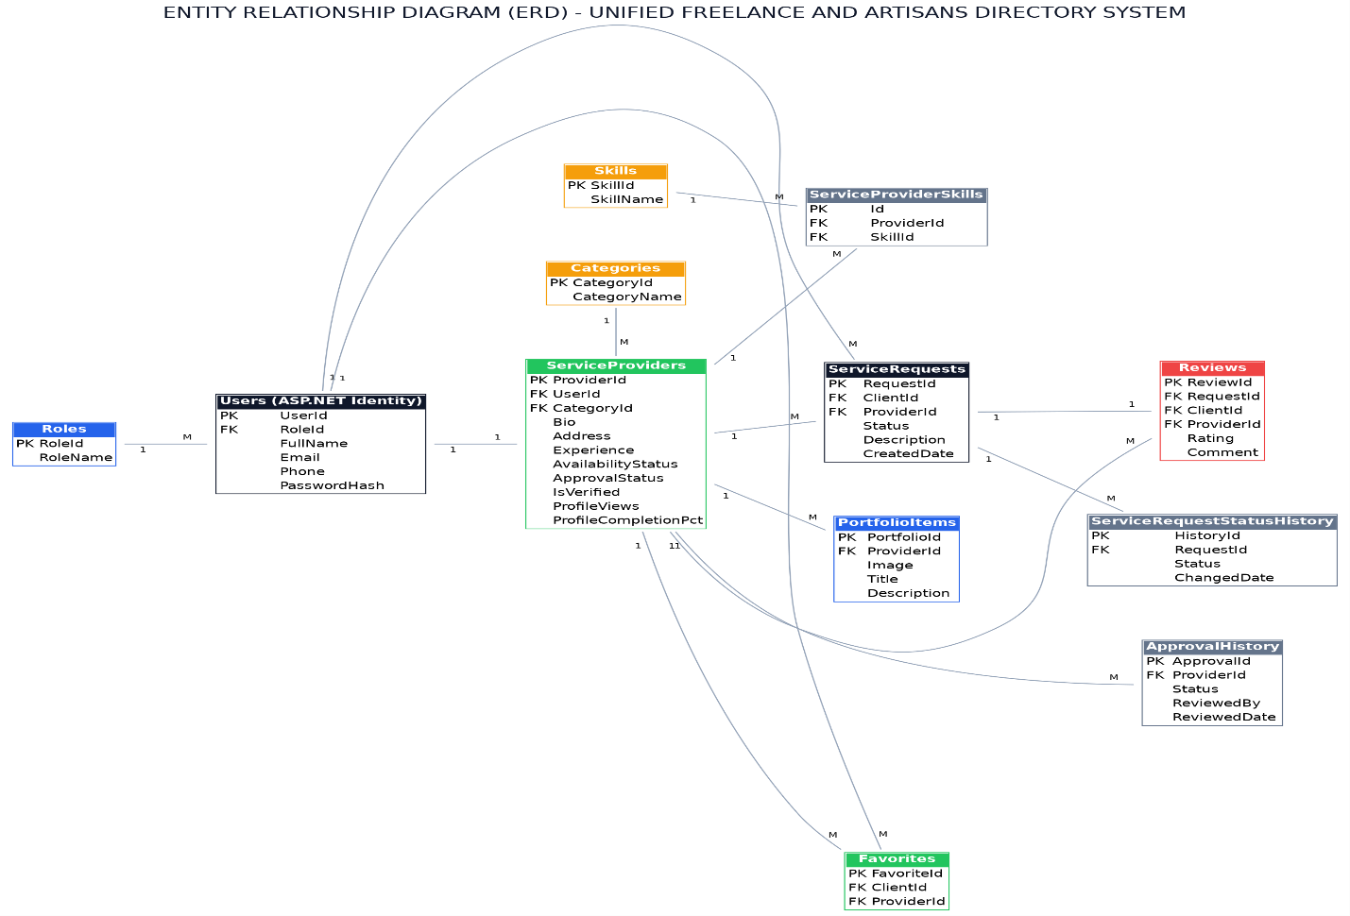
[Figure 4.2 — ERD]
The ERD follows a relational, Code-First model built with Entity Framework Core 9, in which each table has a primary key (PK) and, where required, a foreign key (FK) referencing another table.
The Users table, managed by ASP.NET Core Identity, stores login credentials and a Roles foreign key identifying each account as Administrator, Service Provider, or Client. It is extended by the ServiceProviders table (one-to-one) for provider-specific details: category, bio, experience, availability status, and approval status. Each ServiceProvider belongs to exactly one Category (many-to-one), while a provider's specific competencies are captured separately through Skills, linked via a many-to-many ServiceProviderSkills join table — allowing a provider to be tagged with multiple individual skills even while remaining under a single primary category. Each provider can also upload multiple PortfolioItems (one-to-many), each with an image, title, and description, letting providers showcase past work directly on their public profile.
A Client can submit many ServiceRequest records to a Service Provider (many-to-one on each side), with each request progressing through a defined status lifecycle (Pending, Accepted, Declined, Completed, or Cancelled). Every change to a request's status is written to the ServiceRequestStatusHistory table (one-to-many), producing a complete audit trail. In the same way, every change to a provider's approval status is written to the ApprovalHistory table, giving the Administrator a verifiable record of when and why a profile was approved or rejected. Once a request reaches Completed status, the Client may leave exactly one Review, storing a rating and comment linked to both the request and the provider. Clients can also mark providers as Favorites (many-to-many, via the Favorites table), supporting the "saved providers" feature on the client dashboard.
4.1.3 Deployment Diagram
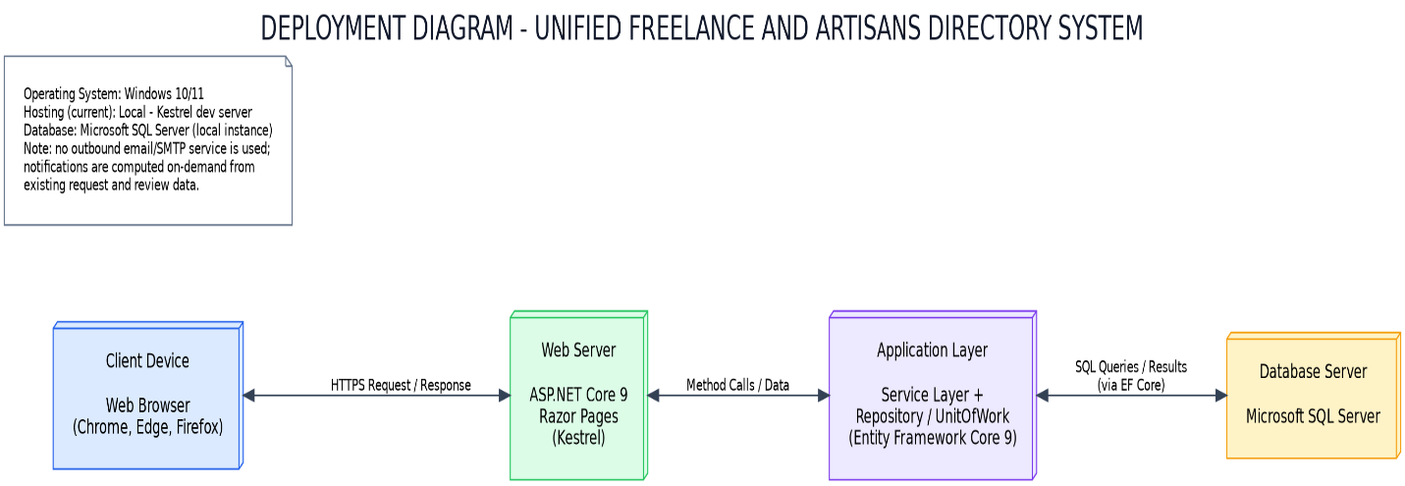
[Figure 4.3 — Deployment Diagram]
The deployment diagram illustrates how the three architectural tiers described in Chapter Three (Section 3.4) map onto hosting components. End users access the Presentation Tier through a standard web browser over HTTPS. Requests are received by the Kestrel web server embedded in the ASP.NET Core 9 application, hosting the Application Tier: Razor Pages, Page Models, the service layer, and the repository/UnitOfWork components implementing the system's business logic. The Application Tier communicates with the Data Tier — a Microsoft SQL Server instance — through Entity Framework Core using parameterized queries, protecting the system against SQL injection. Static assets (CSS, JavaScript, images) are served directly by Kestrel from the wwwroot folder, and ASP.NET Core Identity handles authentication, issuing secure, role-based session cookies to the browser.
4.2 Development Process
The system was developed following an iterative, incremental approach in which the database, backend logic, and user interface were built up module by module rather than all at once, consistent with the Agile SDLC described in Chapter Three (Section 3.2.1). This allowed each role area (Client, Service Provider, Administrator) to be implemented and verified independently before integration into the complete platform.

4.2.1 Requirement Analysis and Planning
The functional requirements identified in Chapter One and the system design produced in Chapter Three were used to define the exact features required for each role, the database tables needed to support them, and the workflow connecting clients, service providers, and administrators. Early planning established the project's core non-transactional boundary: no online payment, wallet, or escrow functionality would be built, keeping the system strictly an informational directory and reputation platform.
4.2.2 Environment Setup
The development environment was configured using Visual Studio Code, the .NET SDK 9.0, and Microsoft SQL Server. The ASP.NET Core 9 Razor Pages project was scaffolded and connected to a local SQL Server database through a connection string in appsettings.json. Entity Framework Core 9 was added as the project's ORM, and Git was initialized for source control, hosted on GitHub.
4.2.3 Database Design and Migration
Following the ERD in Figure 4.2, each entity — including Users, ServiceProviders, Categories, Skills, ServiceProviderSkills, PortfolioItems, ServiceRequests, ServiceRequestStatusHistory, ApprovalHistory, Reviews, and Favorites — was implemented as a C# class within the domain layer, with relationships configured using EF Core's Code-First approach. Migrations were generated and applied via the .NET CLI (dotnet ef migrations add and dotnet ef database update), automatically creating all tables, primary keys, and foreign key constraints in SQL Server. A database seeder populated the system with demonstration roles, accounts, categories, skills, and service provider profiles so every feature could be tested with realistic data from the outset.
4.2.4 Backend Development
The backend was structured using a clean, layered architecture. For every entity, a generic repository handled standard data operations, with a UnitOfWork class aggregating these repositories to coordinate database transactions. A dedicated service layer sat above the repositories to encapsulate business logic — including the ServiceRequest state machine (Pending → Accepted/Declined → Completed or Cancelled), the profile approval workflow (Draft → PendingApproval → Approved/Rejected), the many-to-many skill assignment logic, and the favorites/saved-provider toggle. Page Models were developed for each Razor Page to handle user input, call the appropriate service methods, and return the correct view. The application was organized into role-isolated Areas — Admin, ServiceProvider, and Client — plus a public Identity area for authentication and a public Pages folder for the search and browse directory, keeping each role's functionality cleanly separated. Role-based authorization was enforced using ASP.NET Core Identity together with area-level authorization policies.
4.2.5 Frontend Development
The interface was built using HTML5, CSS3, and Bootstrap 5 within Razor views. A role-aware dashboard shell — sidebar and top bar — was created for the Admin, Service Provider, and Client areas, while public-facing pages (landing page, directory search, provider profile pages) retained a conventional top-navigation layout. A defined color palette and consistent typography were applied across the interface for a professional, trustworthy appearance. Chart.js was integrated into the Administrator dashboard to visualize platform statistics such as monthly service request volume, most-requested categories, and request status distribution.
4.2.6 Testing and Debugging
Each module was tested manually as it was completed, using the demonstration accounts created by the seeder. Issues identified and resolved included data annotation and validation attribute errors, namespace conflicts introduced during the pivot from an earlier MVC-based structure to Razor Pages, and logic errors in request-status transitions. A compilation error caused by an incorrectly qualified enumeration reference in the shared dashboard layout was also identified and corrected prior to final delivery. A more detailed account of the testing strategy is provided in Chapter Three, and full testing results are presented in Chapter Five.
4.2.7 Deployment (Local)
The completed system was deployed locally for demonstration and User Acceptance Testing purposes, run using the built-in Kestrel web server (dotnet run) and accessible through a browser at its local development URL, with SQL Server running as a local service. [Update this subsection if the system was subsequently deployed to a cloud or shared web hosting environment, and reference the specific host used.]
4.3 User Interface Design
The interface was designed to be simple, professional, and role-specific, so each user sees only the information and actions relevant to them. Bootstrap 5 ensures the interface is responsive across desktop and mobile. Figures 4.4 onward show screenshots taken directly from the working system, branded "UFAD Garowe."

[Figure 4.4 — Public Landing Page]
presents the UFAD Garowe hero section with the tagline "Trusted local professionals, one search away," a combined keyword-and-category search bar, and two primary calls to action — "Find Service Providers" and "Become a Service Provider" — alongside top navigation for Home, Find Experts, Why UFAD, and FAQ.
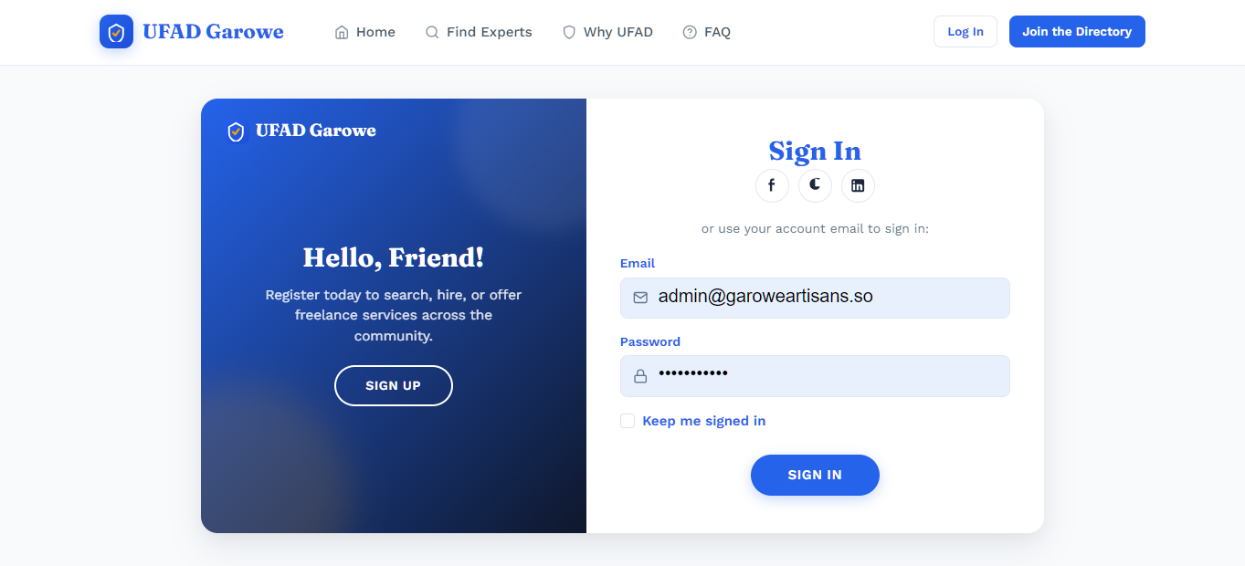
[Figure 4.5 — Login Page]
displays the "Sign In" form with email and password fields, a "Keep me signed in" option, and secondary social sign-in icons, presented alongside a branded welcome panel inviting new users to register.
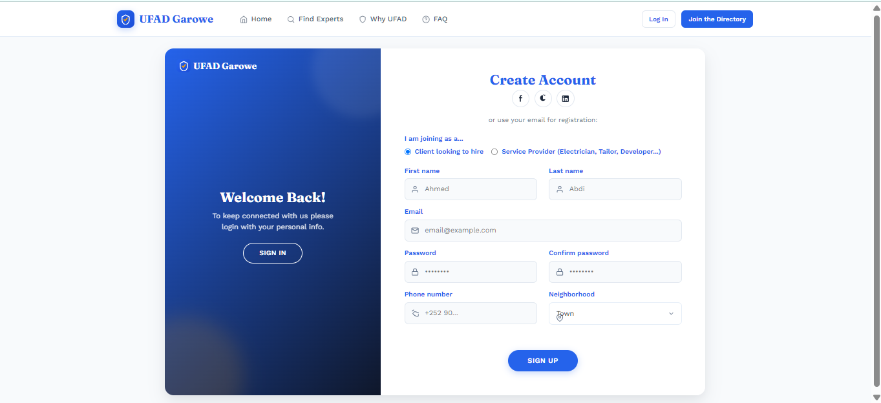
[Figure 4.6 — Registration Page]
— displays the "Create Account" form, which begins by asking the user to select a role — "Client looking to hire" or "Service Provider (Electrician, Tailor, Developer…)" — before collecting first and last name, email, password and confirmation, phone number, and neighborhood, demonstrating the role-selection step that determines which Area (Client or Service Provider) the new account is provisioned into.
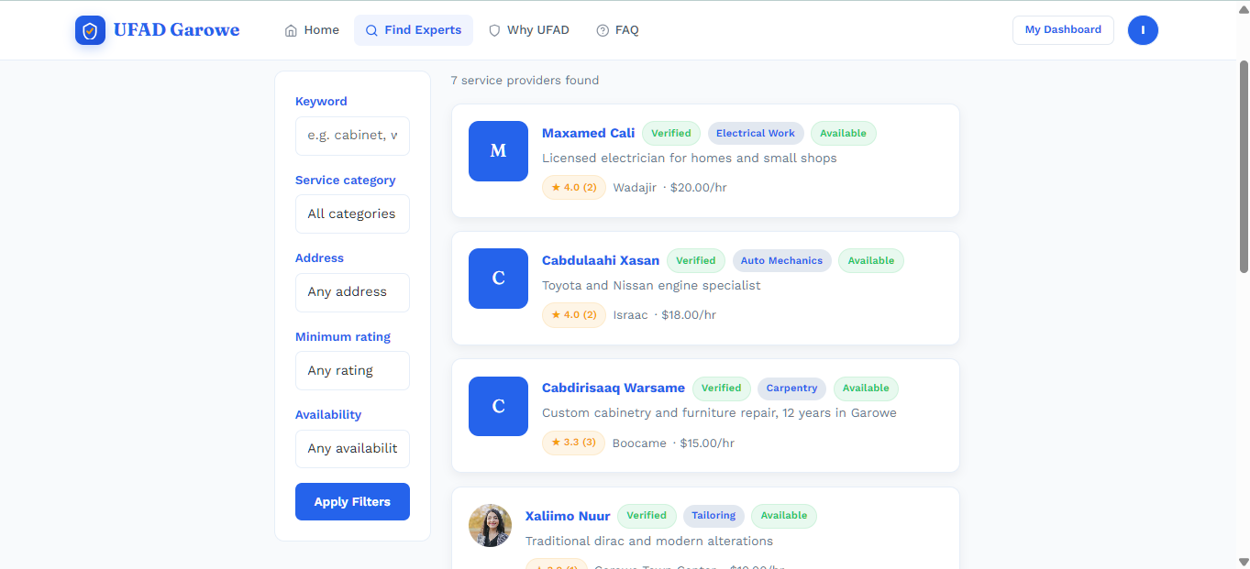
[Figure 4.7 — Find Service Providers (Search Results)]
— shows the directory search page with a filter sidebar (keyword, service category, address, minimum rating, availability) and a results list of matching providers, each card displaying the provider's name, verification badge, category tag, availability status, star rating with review count, location, and hourly rate — directly implementing the categorized search objective set out in Chapter One (Section 1.3).
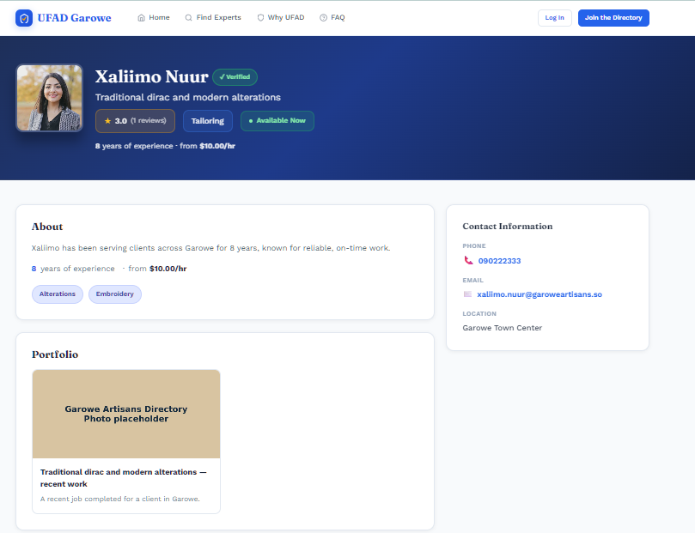
[Figure 4.8 — Public Service Provider Profile ("Provider Details")]
— shows an individual provider's public profile page (e.g., Maxamed Cali, a verified electrician), including their verification badge, category, availability, rating, years of experience and hourly rate, an "About" section, contact information (phone, email, location), and a Portfolio section displaying uploaded work samples — giving clients the verified, at-a-glance trust signals identified as missing from legacy word-of-mouth hiring in Chapter One and Chapter Two.
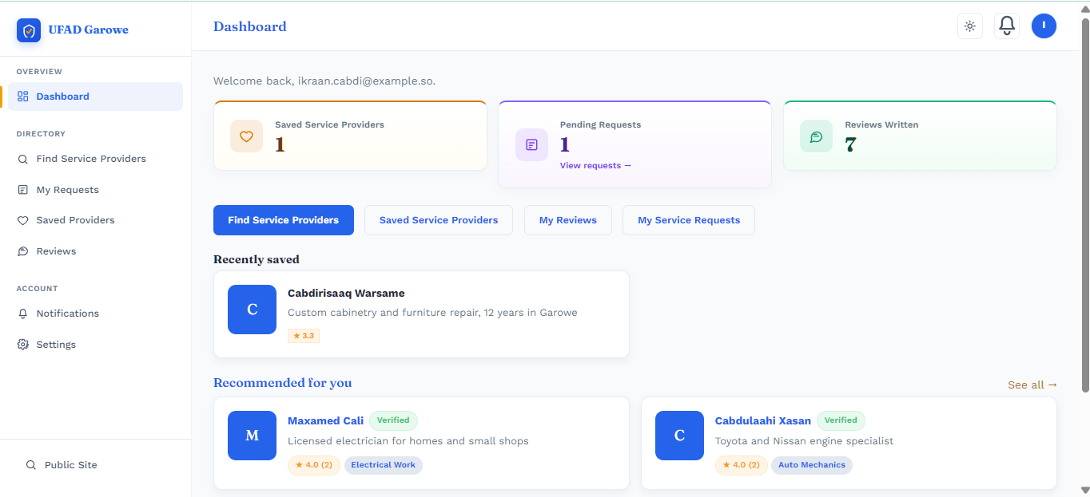
[Figure 4.9 — Client Dashboard]
— displays the client's saved service providers, pending requests, and reviews written, with quick access to search, saved providers, reviews, and service request history, plus a notifications entry and profile settings.
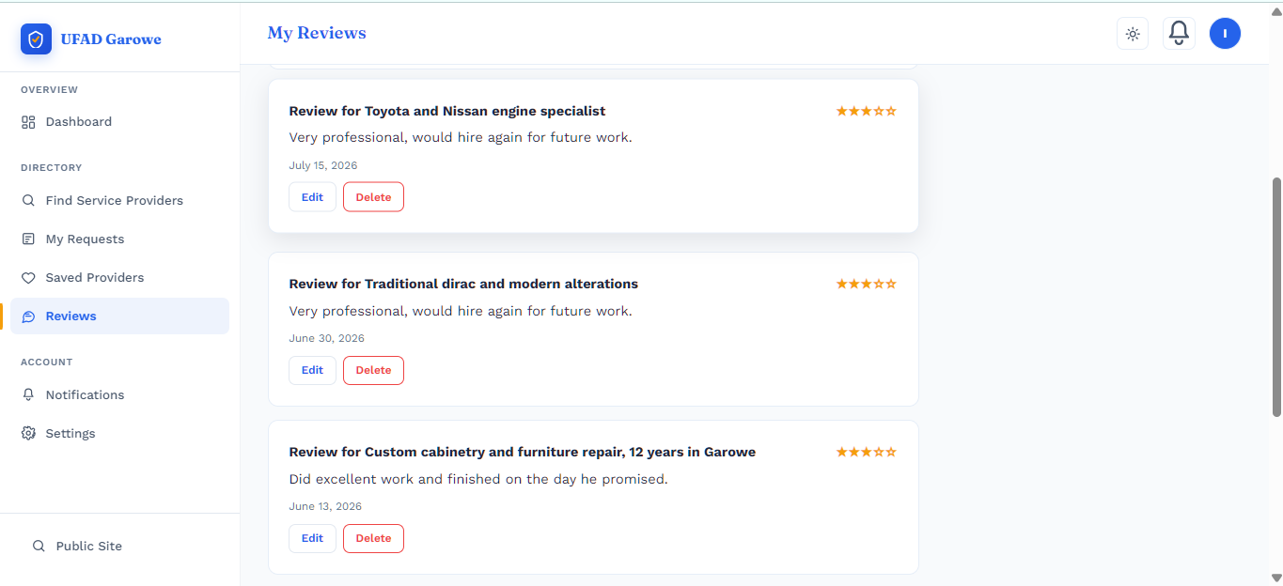
[Figure 4.10 — Client "My Reviews" Page]
— shows the client's own review history, listing each review the client has written (service, star rating, and comment) with Edit and Delete actions available for each entry.
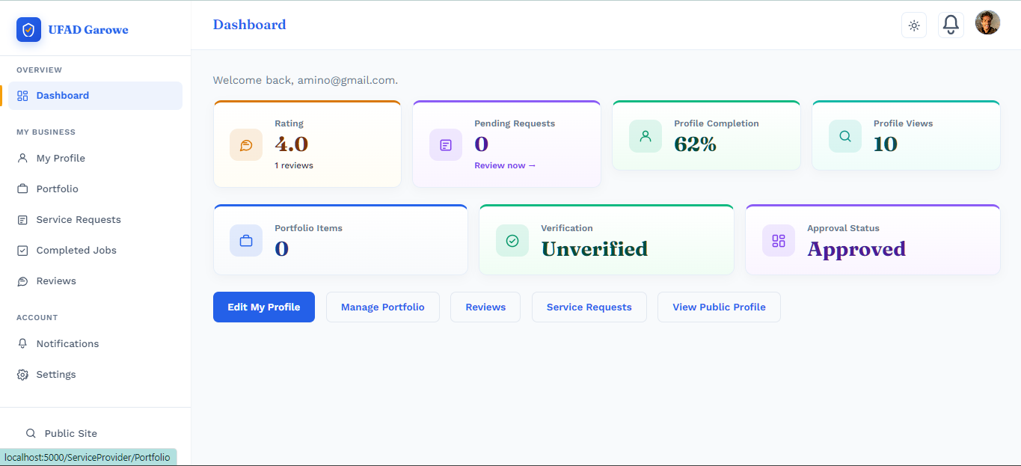
[Figure 4.11 — Service Provider Dashboard]
— displays the provider's current rating, pending requests, profile completion percentage, profile view count, portfolio item count, verification status, and approval status, alongside quick actions to edit their profile, manage their portfolio, view reviews, manage service requests, and view their public profile.
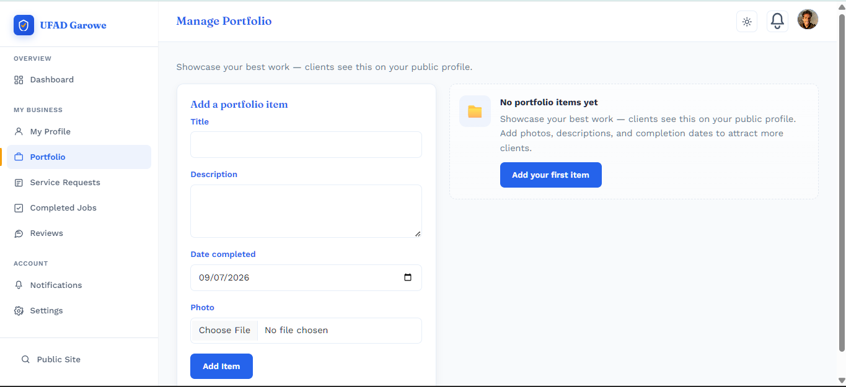
[Figure 4.12 — Manage Portfolio Page]
— shows the provider-facing portfolio management screen, including the "Add a portfolio item" form (title, description, date completed, photo upload) and an empty-state prompt encouraging providers to add their first item — directly supporting the PortfolioItems feature described in Section 4.1.2.
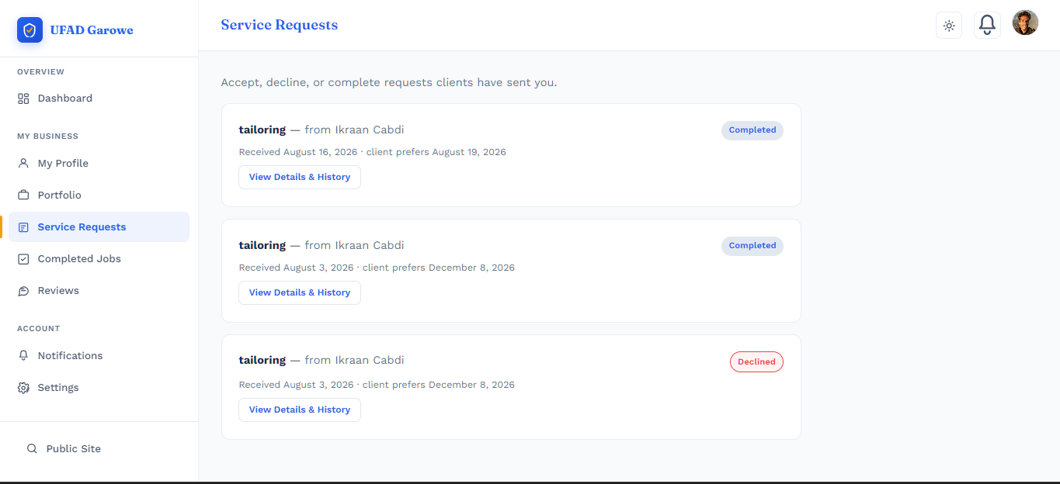
[Figure 4.13 — Service Provider "Service Requests" Page]
— shows the provider's incoming request list, each entry displaying the request title, the client who sent it, the date received and preferred date, and its current status (e.g., Completed, Declined), with a "View Details & History" action per request, reflecting the ServiceRequestStatusHistory audit trail described in Section 4.1.2.
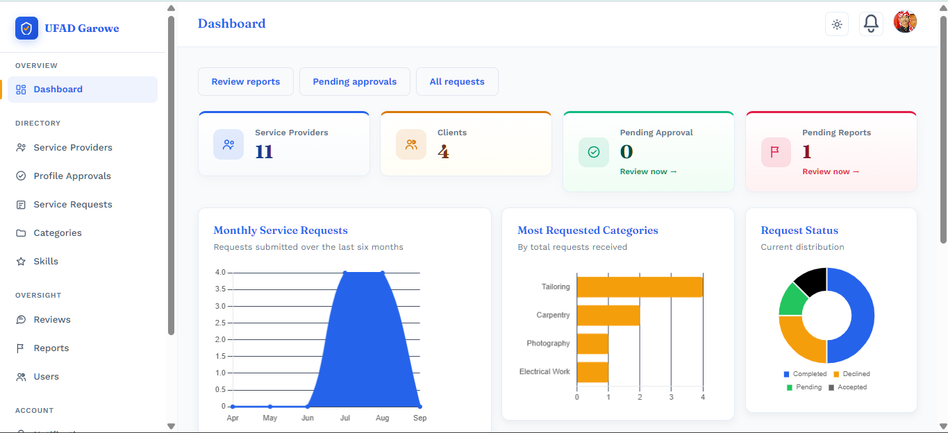
[Figure 4.14 — Administrator Dashboard]
— presents platform-wide statistics (total service providers, total clients, pending approvals) through Chart.js visualizations of monthly service requests, most-requested categories, and request status distribution, alongside navigation for managing service providers, profile approvals, service requests, categories, skills, and reviews.
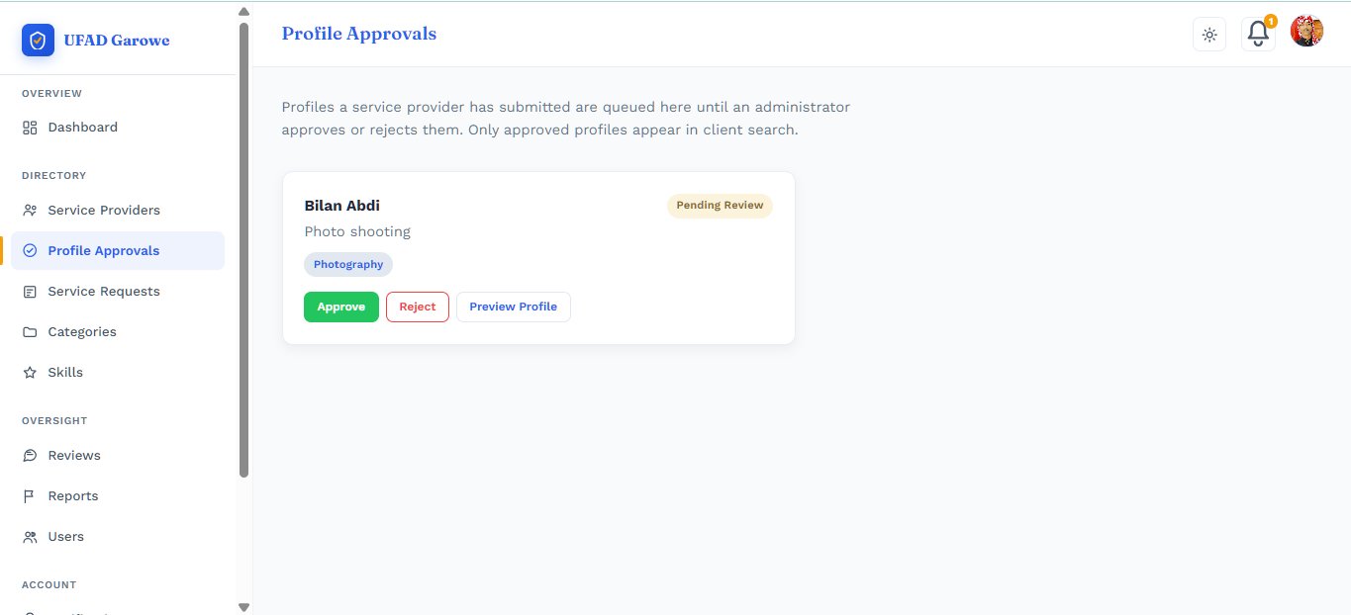
[Figure 4.15 — Admin Profile Approvals Page]
— shows the administrator's queue of provider profiles awaiting review, with each entry displaying the applicant's name, service description, category, and Approve, Reject, and Preview Profile actions — directly implementing the ApprovalStatus workflow (Draft → Pending Approval → Approved/Rejected) described in Section 4.1.2.
[Figure 4.16 — Admin "Service Requests" Page (Platform-Wide)]
— shows the administrator's platform-wide view of every service request sent between clients and providers, listing the request title, client, provider, current status, and date sent, giving the Administrator the centralized oversight role identified as missing from legacy networks in Chapter Two (Section 2.3.4).
Across all three role-based dashboards, the same sidebar-and-topbar layout, color palette, and component styling were reused, giving the platform a consistent, cohesive visual identity while tailoring the content of each screen to its specific user role.
4.4 Chapter Summary
This chapter presented the system diagrams, development process, and user interface implementation of the Unified Freelance and Artisans Directory System. The Use Case Diagram and ERD translated the requirements and architecture from earlier chapters into concrete system models — including the skill-tagging, portfolio, and favorites features that extend beyond the basic directory concept — the development process described the platform's construction using ASP.NET Core 9, Entity Framework Core 9, and SQL Server, and the user interface walkthrough demonstrated how the finished system presents role-specific functionality to clients, service providers, and administrators. The next chapter presents the results of system testing and evaluates the platform's performance against the objectives set out in Chapter One.
basic directory concept — the development process described the platform's construction using ASP.NET Core 9, Entity Framework Core 9, and SQL Server, and the user interface walkthrough demonstrated how the finished system presents role-specific functionality to clients, service providers, and administrators. The next chapter presents the results of system testing and evaluates the platform's performance against the objectives set out in Chapter One.

CHAPTER FIVE: RESULTS AND DISCUSSION
5.1 Introduction
This chapter presents the results of testing conducted on the completed Unified Freelance and Artisans Directory System and discusses what those results mean in relation to the objectives set out in Chapter One and the design decisions made in Chapters Three and Four. Testing was carried out as developer-led functional testing across the system's core modules — authentication, profile management, the approval workflow, search, the service request lifecycle, reviews, favorites, and administrative oversight — following the test plan described in Chapter Three (Section 3.2). The chapter is organized as follows: Section 5.2 presents the functional testing results, Section 5.3 discusses what these results indicate about system performance and reliability, Section 5.4 interprets the findings against the study's objectives, Section 5.5 states the limitations of the testing conducted, and Section 5.6 closes with a chapter summary.
5.2 Testing Results
A structured set of 20 functional test cases was executed directly on the deployed system, covering every major module identified in Chapter Four. Table 5.1 presents the complete results.
Table 5.1 — Functional Test Results
ID | Module | Test Case | Expected Result | Result
T01 | Authentication | Register a new Client account | Account created, redirected to dashboard | Pass
T02 | Authentication | Register a new Service Provider account | Account created, prompted to complete profile | Pass
T03 | Authentication | Log in with correct credentials | Redirected to correct role dashboard | Pass
T04 | Authentication | Log in with incorrect password | Clear error shown, login blocked | Pass
T05 | Profile Management | Provider fills profile (bio, category, skills, address) | Fields save, profile completion % updates | Pass
T06 | Profile Management | Provider uploads a portfolio item | Item appears on portfolio and public profile | Pass
T07 | Approval Workflow | Provider submits profile for approval | Status changes to Pending Approval | Pass
T08 | Approval Workflow | Admin approves the profile | Status changes to Approved, becomes searchable | Pass
T09 | Approval Workflow | Admin rejects a profile | Status changes to Rejected | Pass
T10 | Search | Client searches by category | Only Approved providers in category appear | Pass
T11 | Search | Client searches with no matches | Empty state shown, no crash | Pass
T12 | Service Request | Client sends a request to a provider | Request appears as Pending on both dashboards | Pass
T13 | Service Request | Provider accepts request | Status updates to Accepted on both sides | Pass
T14 | Service Request | Provider declines request | Status updates to Declined | Pass
T15 | Service Request | Provider marks request Completed | Status updates, request eligible for review | Pass
T16 | Reviews | Client leaves a review after completion | Review saved, average rating updates | Pass
T17 | Reviews | Client attempts review before completion | Review option blocked/unavailable | Pass
T18 | Favorites | Client saves a provider | Provider appears under Saved Providers | Pass
T19 | Admin | Admin views dashboard statistics | Correct counts of providers/clients/requests shown | Pass
T20 | Responsive Design | Site opened on a mobile-sized screen | Layout intact, navigation usable | Pass
Of the 20 test cases executed, all 20 passed (100%). Every core module — authentication, profile management, the approval workflow, search, the full service-request lifecycle, reviews, favorites, and administrative oversight — functioned according to its expected behavior.
5.3 System Performance Analysis
The 100% pass rate across core modules indicates that the system's primary functional pathways — registration, authentication, profile management, the approval workflow, search, the full service-request lifecycle, and the review and favorites features — operate as designed. Notably, every workflow involving the system's audit-trail features (ServiceRequestStatusHistory and ApprovalHistory, described in Chapter Four) correctly reflected status transitions on both the initiating and receiving user's dashboard, confirming that the layered service/repository architecture described in Chapter Three correctly propagates state changes through the application without data loss or desynchronization between roles. The responsive design test (T20) further confirmed that the Bootstrap 5-based interface remains usable on smaller screen sizes, which is relevant given that a meaningful share of users in Garowe may access the platform primarily via mobile browsers, consistent with the mobile-penetration figures discussed in Chapter One (Kemp, 2025).
5.4 Interpretation of Findings
These results indicate that the core objectives defined in Chapter One (Section 1.3) were substantially achieved. Objective 2 (secure authentication and profile management) is functionally met, with the system correctly authenticating valid users and rejecting invalid credentials with an appropriate error response. Objective 3 (categorized search) and Objective 4 (feedback and rating module) both passed their respective test cases cleanly, supporting the conclusion that the system directly addresses the information asymmetry and trust-gap problem identified in Chapter One's problem statement (Section 1.2) and grounded theoretically in Akerlof (1970) and Tadelis (2016) in Chapter Two: a client can now request, complete, and rate a service in a single auditable flow, which the pre-existing word-of-mouth system could not offer.
5.5 Limitations of Testing
The testing reported in this chapter was conducted solely by the developer, exercising each function directly rather than through independent multi-user testing. As such, these results confirm that the system's functional pathways work as designed under controlled, single-user conditions, but they do not yet capture how independent first-time users — particularly manual artisans and clients with lower digital literacy, as discussed in Chapter One — would experience the interface without developer familiarity guiding their actions. A structured User Acceptance Testing (UAT) round with independent participants, as outlined in the methodology (Chapter Three, Section 3.2), was planned but not completed within the available timeframe, and is recommended as the immediate next step before wider deployment, and as an avenue for future work.
5.6 Chapter Summary
This chapter presented the results of structured functional testing performed on the Unified Freelance and Artisans Directory System, covering 20 test cases across all major modules. All twenty tests passed, confirming that the system's core functional pathways operate as designed. These results support the conclusion that the system meets its core functional objectives from Chapter One, while highlighting the value of independent user testing as a next step. The following chapter presents the overall conclusions of this study and recommendations for future work.

CHAPTER SIX
CONCLUSION AND RECOMMENDATIONS
6.0 Introduction
This final chapter draws together the research problem, design decisions, and testing results presented across the preceding five chapters. Section 6.1 summarizes the study's key findings, Section 6.2 presents the overall conclusions drawn from the project, Section 6.3 offers recommendations for future work, and Section 6.4 closes with final remarks.
6.1 Summary of Findings
Chapter One established that Garowe's independent artisans and freelancers suffer from limited digital visibility, while clients face slow, unverified, and often unsafe word-of-mouth hiring — a two-sided problem rooted in information asymmetry (Akerlof, 1970) that is worsened, not solved, by the fact that informal employment dominates the regional labor market (ILO, 2024). Chapter Two's review of related literature and existing platforms (Upwork, TaskRabbit) confirmed that no existing solution — global or local — was structurally suited to Garowe: global platforms depend on financial and infrastructural overhead the local context cannot support, while legacy word-of-mouth networks offer no verification, no accountability, and no way to scale beyond a person's immediate social circle.
Chapter Three set out a mixed-methods, Agile-based methodology, and Chapter Four documented the resulting system: the Unified Freelance and Artisans Directory (UFAD Garowe), a three-tier ASP.NET Core 9 Razor Pages application with a layered repository/service architecture, role-isolated Client, Service Provider, and Administrator areas, and a relational SQL Server database supporting profile approval, categorized and skill-tagged search, a portfolio system, a full service-request lifecycle with audit trails, a review and rating system, and a favorites feature — all deliberately excluding financial transaction handling to keep the platform a focused, non-transactional directory.
Chapter Five's functional testing showed that the system's core pathways work as designed: all 20 test cases passed (100%), covering authentication, profile management, the approval workflow, search, the complete service-request lifecycle, reviews, favorites, and administrative oversight. Testing was conducted by the developer alone; independent multi-user UAT was planned but not completed within the available timeframe.
6.2 Conclusions
Based on the findings summarized above, this study concludes that a localized, non-transactional web directory is both a technically feasible and a contextually appropriate response to the service-matching problem identified in Garowe. The system successfully unifies two populations — manual artisans and digital freelancers — that comparable platforms elsewhere typically treat as separate markets, and it operationalizes the trust and reputation mechanisms identified in the literature (Tadelis, 2016) through its approval workflow, verification badge, and review system, rather than relying on the financial-transaction infrastructure that makes global platforms unworkable locally.
The five specific objectives set out in Chapter One (Section 1.3) were substantially met: the underlying service-matching problem was investigated and documented (Objective 1); secure registration, authentication, and profile management were implemented and tested successfully (Objective 2); categorized, filterable search was implemented and verified (Objective 3); a public rating and review module was implemented and verified (Objective 4); and the completed system was tested against defined functional test cases, all of which passed (Objective 5), though independent UAT remains the key next step to confirm usability beyond developer-led testing. The honestly-scoped limitations of testing do not undermine this conclusion — they demonstrate that the system was evaluated rigorously rather than being presented as complete without evidence.

6.3 Recommendations for Future Work
The following recommendations are proposed for extending and strengthening the system beyond this thesis:
- Conduct independent User Acceptance Testing. As noted in Chapter Five, testing to date was developer-led. A structured UAT round with a small group of real artisans and clients — using the test script and task list already prepared for this purpose — should be completed before any wider deployment, to validate usability for users without developer familiarity with the interface.
- Resolve the admin Reports feature. The administrator dashboard currently includes Reports/"Pending Reports" navigation elements that are not yet backed by a working content-moderation feature. This should either be implemented as a genuine flagging/moderation system for reviews and profiles, or removed from the interface until it is, to avoid presenting non-functional navigation to users or examiners.
- Extend the notification system. Notifications are currently implemented as a computed, read-only feed rather than a persisted, independently deliverable channel. Future work could introduce a proper Notifications table together with in-app read/unread tracking, and optionally email delivery, so users are not solely dependent on visiting the dashboard to see updates.
- Introduce a mobile-friendly or native mobile version. The current system is a responsive web application; given Somalia's mobile-first internet usage pattern (Kemp, 2025), a dedicated mobile app or a Progressive Web App (PWA) version could improve accessibility for users who rely primarily on smartphones.
- Explore optional payment integration as a separate module. This thesis deliberately scoped out financial transactions to keep the system simple and locally appropriate (Chapter One, Section 1.4). A future iteration could explore an optional, clearly separated mobile-money integration (e.g., EVC Plus or similar local providers) for users who want it, without making it mandatory for the directory's core function.
- Expand category and skill data as the platform grows. As real providers register, the Categories and Skills tables should be reviewed and expanded to reflect the actual range of services offered in Garowe, rather than relying solely on the demonstration seed data used during development.
- Deploy to a persistent hosting environment. The system currently runs on a local Kestrel development server. Moving to a proper hosting environment (cloud or local shared hosting) would allow real users to access the platform beyond the academic demonstration period.
6.4 Final Remarks
The Unified Freelance and Artisans Directory System demonstrates that a modest, carefully scoped web application — built without complex payment infrastructure — can meaningfully address a real, locally observed gap between skilled independent workers and the clients who need them in Garowe. The project's value lies not only in the working system delivered, but in the honest testing record behind it: a documented full pass rate across all defined test cases, and a clear, specific list of what remains to be done — starting with independent UAT — before the platform is ready for wider use. That combination — a functioning, verified system plus an accurate account of its current limitations — is the strongest foundation for the recommendations above and for any continued work on the platform after this thesis.
6.5 References
Akerlof, G. A. (1970). The market for "lemons": Quality uncertainty and the market mechanism. The Quarterly Journal of Economics, 84(3), 488–500. https://doi.org/10.2307/1879431
International Labour Organization. (2024). Five facts about the informal economy in Africa. https://www.ilo.org/resource/news/five-facts-about-informal-economy-africa
Kemp, S. (2025). Digital 2025: Somalia. DataReportal. https://datareportal.com/reports/digital-2025-somalia
Tadelis, S. (2016). Reputation and feedback systems in online platform markets. Annual Review of Economics, 8, 321–340. https://doi.org/10.1146/annurev-economics-080315-015325

